**Internship at the International Education Office,**

**University of Agder, Norway**

The **University of Agder (UiA)** is looking for two interns / Erasmus+ trainees to work in our welcome centre, the Global Lounge.

**Who are we?**

The University of Agder (UiA) is a young and dynamic university, recognised for its modern teaching and research facilities and innovative use of technology and communication media. UiA has approximately 12 000 students in two campuses in the very south of Norway. The Intern will be based in the main campus in the city of [Kristiansand](https://www.visitnorway.com/places-to-go/southern-norway/kristiansand/) and will work closely with the staff from the International Education Office and other departments. The main work-place will be our Global Lounge, an area designated to welcome and support International and Norwegian students, guests and staff.

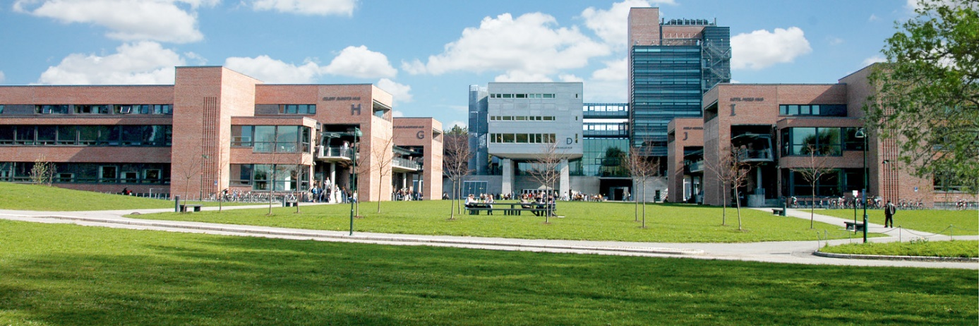

**Your fields of responsibility:**

* First point of contact for Global Lounge
* Supporting mobility team (incoming and outgoing students)
* Being the contact point between the international students and the International Education Office
* Help with marketing / promotion, social media and public relations
* General administrative support (answering phone calls and e-mails, processing applications)
* Show the University to international guests
* Help with organising activities and events in Global Lounge for students, staff and guests
* Support with promotion and running of our [Summer School in European Integration](https://www.uia.no/en/studier/european-integration-summer-school-eiss)

**Who are we looking for?**

* Student enrolled at a bachelor’s or master’s level or a recent graduate
* Fluent English spoken and written
* Strong communication and customer service skills
* Computer skills
* Marketing and administrative experience
* Flexible and able to work independently
* Due to immigration regulations, the interns need to be European Citizens or have a permanent right to stay in a EU / EAA country

**Period / time scale:**

We would like both interns to stay for 9 - 10 months and to start by the second week of August 2018, finishing at the end of May 2019. However, we can also consider one intern for 9-10 months (August to end of May) and one for 5 months (August to December).

**Payment:**

The internship is financed through the Erasmus+ program. The exact amount of your grant depends on your home country. For more detailed information please contact the International office of your university.

**What can we offer you?**

* Varied work experience
* Free single-room accommodation in student housing
* Free Norwegian Language course
* The opportunity to join international students for trips and events

**To apply:**

* Send your CV together with a one-page cover letter describing why you are interested in the internship
* Supply the names and contact details of two referees (teachers, former employers, etc.) who can be contacted by us
* A Skype interview will be required if short-listed
* Applications should be sent by e-mail to [aase.galteland@uia.no](mailto:aase.galteland@uia.no) by 27th May.